Tic Tac Toe Game

Or it’s sometime called noughts and crosses! Start with a two player game, where each player takes a turn to put an X or a O into a box and if you get a line of X’s or O’s you win!

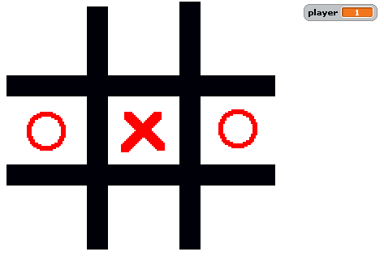

Some key things

* Draw The Board (it could be the background or it could be a sprite)
* How about some Sprites for the O and X to appear
* Resetting for the next game
* How do you know whose go it is
* How do you know if a player has a winning line

Some hints:

* Visually you can see what is happening but how can your program test if you have filled in a line – think of the squares as a grid of 1-9 squares – how would you represent that in Scratch?
* Test your program with one line
* Then build it out for three lines

Then improve it:

* Draw a line over the winning squares!
* Scoreboard – keep tabs on who is winning
* Make a sound
* And if that’s all too easy – Make the second player 2 the computer!

Don’t forget to load the project back to the Scratch site and show the class!